Foodeast Limited Partnership

Hawke’s Bay Food Innovation Hub
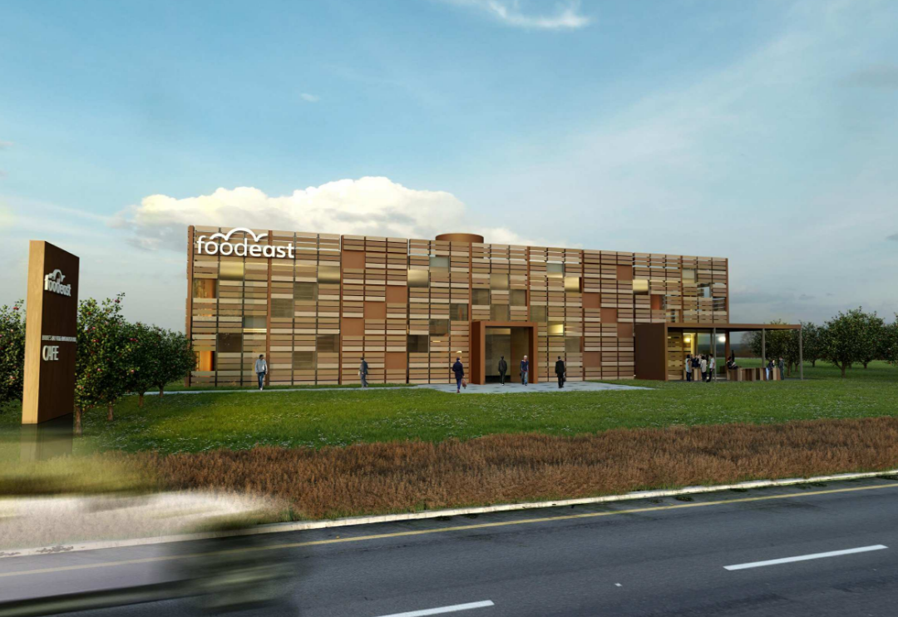
Project Summary  The Hawkes Bay Food Innovation Hub project at the corner of Elwood Rd and Hanui Rd, Hastings, consists of a new development of a single level industrial building (Building B) and a two-level commercial building with an atrium (Building A).  Building A will be 8m high at the roof level. Building B will be 8m high at the apex and 6m high at the knee and be subdivided to 3 industrial tenancies.  Automatic sprinkler, smoke detection system, and smoke extraction system provided to the building A.  Crossfire Value to Project  Crossfire investigated the multiple compliance options of fire alarm systems and fire separation arrangements for the project during the design stage.  We developed the fire design to the alternative solution (combination of the C/AS2 and C/VM2) to meet the complex requirements from building code, clients, building authority and design team. | Client  Foodeast Limited Partnership.  Architect  RTA Studio  Date  Completion 2022  Project Value  $20m

